🔹 1. What is Routing?
Routing is the process of selecting the best path for data (packets) to travel from a source network to a destination network.
- It happens at Layer 3 (Network Layer) of the OSI model.
- Devices called routers make these decisions using a routing table.
👉 In simple terms:
Routing = “How does data know where to go?”

🔹 2. Types of Routing

1. Static Routing
- Routes are manually configured by a network administrator.
- Example:
- ip route 192.168.2.0 255.255.255.0 10.0.0.2
- ✅ Pros: Simple, secure
- ❌ Cons: Not scalable, no automatic updates

2. Dynamic Routing
- Routers automatically learn routes using protocols.

Common protocols:
- RIP (Routing Information Protocol)
- OSPF (Open Shortest Path First)
- EIGRP (Cisco proprietary)
- BGP (used on the internet)
- ✅ Pros: Scalable, adaptive
- ❌ Cons: More complex

3. Default Routing
- A “catch-all” route used when no specific route is found.
Example:
0.0.0.0/0 → next-hop
👉 Meaning: “If you don’t know where to go, send it here.”

🔹 3. Connected and Local Routes

✅ Connected Route
- A network directly attached to the router interface.
- Automatically added when an interface is up.
Example:
192.168.1.0/24 → directly connected
👉 Means: Router can reach this network without another router

✅ Local Route
- Represents the router’s own IP address on an interface.
Example:
192.168.1.1/32 → local
👉 Means: “This IP belongs to me.”

🔹 4. What Does “Router Matching a Destination” Mean?
When a packet arrives, the router:
- Looks at the destination IP address
- Searches its routing table
- Finds a route that matches that destination
👉 This process is called route matching
Example:
- Packet destination: 192.168.1.10
- Router checks routing table for a matching network

🔹 5. What is Next-Hop?
The next-hop is:
👉 The next router (or gateway) where the packet should be sent on its way to the final destination.
Example:
Destination: 192.168.2.0/24
Next-hop: 10.0.0.2
👉 Meaning:
- “To reach 192.168.2.0, send the packet to router at 10.0.0.2”

🔹 6. What is Most Specific Matching Route? (Longest Prefix Match)
This is a very important concept 🔥
👉 When multiple routes match a destination, the router chooses the most specific one.

✔ Most specific = longest subnet mask (largest prefix)

Example:
Routing table:
192.168.0.0/16
192.168.1.0/24
192.168.1.128/25
Destination IP:
192.168.1.130

Matching routes:
- /16 → matches
- /24 → matches
- /25 → matches ✅
👉 Router chooses:
192.168.1.128/25
✔ Because it is the most specific (longest prefix)

🔑 Key Idea:
- /25 is more specific than /24
- /24 is more specific than /16
👉 This is called Longest Prefix Match (LPM)

🔹 Quick Summary
- Routing → Finding the best path for packets
- Static routing → Manual
- Dynamic routing → Automatic
- Connected route → Directly attached network
- Local route → Router’s own IP
- Matching destination → Router finds route for destination IP
- Next-hop → Next device to forward packet to
- Most specific match → Route with longest prefix wins

🔹 1. IP Configuration Commands on an Interface (Cisco IOS)

✅ Enter Interface Configuration Mode
enable
configure terminal
interface GigabitEthernet0/0

✅ Assign an IPv4 Address
ip address 192.168.1.1 255.255.255.0
👉 This sets:
- IP = 192.168.1.1
- Subnet mask = /24

✅ Enable the Interface
no shutdown
👉 By default, interfaces are administratively down, so this command turns it ON.

✅ Configure IPv6 Address
ipv6 address 2001:db8:1::1/64

✅ Enable IPv6 Routing (Global command)
ipv6 unicast-routing

✅ Add Description (Optional but good practice)
description Link to Switch or LAN

✅ Exit Configuration
end

🔹 2. Verification Commands

Check Interface Status
show ip interface brief
👉 Shows:
- IP address
- Status (up/down)

Check Routing Table
show ip route
👉 This is where you see C and L routes 👇

🔹 3. Meaning of C and L in Routing Table
When you configure an IP on an interface, the router automatically creates two routes:

✅ C → Connected Route
Example:
C 192.168.1.0/24 is directly connected, GigabitEthernet0/0
👉 Meaning:
- This network is directly connected to the router
- No need for a next-hop router
✔ The router can send packets directly out that interface

✅ L → Local Route
Example:
L 192.168.1.1/32 is directly connected, GigabitEthernet0/0
👉 Meaning:
- This is the router’s own IP address
- Used to receive packets destined to the router itself
✔ /32 = single host (exact IP)

🔹 4. Important Relationship Between C and L
When you configure:
ip address 192.168.1.1 255.255.255.0
👉 Router automatically creates:
Type | Route
C | 192.168.1.0/24
L | 192.168.1.1/32

🔹 5. Simple Visualization
Interface: G0/0
IP: 192.168.1.1/24
Routing Table:
C → Network (192.168.1.0/24)
L → Router IP (192.168.1.1/32)

🔹 6. Why Both Are Needed
- C route → helps router reach other devices in the network
- L route → helps router recognize packets meant for itself

🔹 7. Bonus: Example Full Configuration
enable
configure terminal
interface GigabitEthernet0/0
ip address 192.168.10.1 255.255.255.0
no shutdown
description LAN Interface
end

🔹 8. Sample Output (show ip route)
C 192.168.10.0/24 is directly connected, GigabitEthernet0/0
L 192.168.10.1/32 is directly connected, GigabitEthernet0/0

🔥 Quick Exam Tips
- C = Connected network
- L = Local (router’s IP)
- L is always /32
- Both appear automatically after IP configuration
If you do not put the “no shutdown” command, the Local and Connected Routes will not appear in the routing table and they cannot be configured.
Connected and Local routes are neither dynamic or static routes

🔹 1. What is a Default Gateway?
A default gateway is:
👉 The device (router) that a host sends packets to when the destination is outside its local network.

Example:
- PC IP: 192.168.1.10/24
- Router IP: 192.168.1.1
👉 Default gateway = 192.168.1.1
✔ Meaning:
“If I don’t know where to send this packet, I send it to the router.”

🔹 2. What is Static Routing (Detailed)
Static routing is when a network administrator manually configures routes in a router.
👉 The router does NOT learn routes automatically.

🔑 Key Characteristics:
- Manually configured
- No routing protocol needed
- Fixed path (does not change unless edited)

✅ Advantages:
- Simple and predictable
- No CPU overhead
- More secure (no route advertisements)

❌ Disadvantages:
- Not scalable
- No automatic failover
- Manual maintenance required

🔹 3. How is the Next-Hop Identified Manually?
👉 You must know the IP address of the next router interface.

🔧 Ways to identify next-hop:

✅ Method 1: From Network Topology
Look at your diagram:
Router1 ---- Router2 ---- Network
10.0.0.2
👉 Next-hop = IP of Router2 interface facing Router1

✅ Method 2: Using Commands
On router:
show ip interface brief
👉 Find:
- Neighbor network
- Interface IPs

✅ Method 3: Logical Thinking
- If destination network is not directly connected
- Send packet to the nearest router toward that network

🔹 4. Static Route Configuration (Cisco Packet Tracer)

🔧 Syntax:
ip route [destination-network] [subnet-mask] [next-hop OR exit-interface]

✅ Example (Using Next-Hop)
ip route 192.168.2.0 255.255.255.0 10.0.0.2
👉 Meaning:
- To reach 192.168.2.0 → send to 10.0.0.2

✅ Example (Using Exit Interface)
ip route 192.168.2.0 255.255.255.0 GigabitEthernet0/0

✅ Example (Both)
ip route 192.168.2.0 255.255.255.0 GigabitEthernet0/0 10.0.0.2

🔹 5. Meaning of show ip route Output
Example:
C 192.168.1.0/24 is directly connected, GigabitEthernet0/0
L 192.168.1.1/32 is directly connected, GigabitEthernet0/0
S 192.168.2.0/24 [1/0] via 10.0.0.2
S* 0.0.0.0/0 [1/0] via 10.0.0.2

🔍 Breakdown:

🔸 Codes:
- C → Connected
- L → Local
- S → Static
- S* → Default static route

🔸 [1/0]
- 1 → Administrative Distance (AD)
- 0 → Metric

🔸 via 10.0.0.2
👉 Next-hop IP

🔹 6. Configuration Using Exit Interface vs Next-Hop

✅ 1. Using Exit Interface
ip route 192.168.2.0 255.255.255.0 GigabitEthernet0/0
👉 Router sends packets out that interface directly

✅ 2. Using Next-Hop
ip route 192.168.2.0 255.255.255.0 10.0.0.2
👉 Router forwards packet to that IP

🔥 3. Using Both (Best Practice)
ip route 192.168.2.0 255.255.255.0 GigabitEthernet0/0 10.0.0.2

🔹 7. Difference Between the Two Techniques
Feature | Exit Interface | Next-Hop
Simplicity | Easy | Needs IP
ARP usage | More ARP | Less ARP
Efficiency | Less efficient | More efficient
Best for | Point-to-point | Multi-access networks

🔍 Output Differences (show ip route)

✅ Using Next-Hop:
S 192.168.2.0/24 [1/0] via 10.0.0.2

✅ Using Exit Interface:
S 192.168.2.0/24 is directly connected, GigabitEthernet0/0

✅ Using Both:
S 192.168.2.0/24 [1/0] via 10.0.0.2, GigabitEthernet0/0

🔹 8. Default Route Configuration

🔧 Syntax:
ip route 0.0.0.0 0.0.0.0 [next-hop]

✅ Example:
ip route 0.0.0.0 0.0.0.0 10.0.0.2

🔍 Output:
S* 0.0.0.0/0 [1/0] via 10.0.0.2
👉 * means Gateway of Last Resort

🔹 9. Key Concepts to Remember
- Default route = least specific (/0)
- Local route = most specific (/32)
- Next-hop = next router IP
- Static route = manually configured path
- Exit interface vs next-hop affects routing behavior and output

🔥 Final Quick Summary
- Default gateway → where hosts send unknown traffic
- Static routing → manual route setup
- Next-hop → IP of next router
- show ip route → shows routing decisions
- /0 → least specific
- /32 → most specific

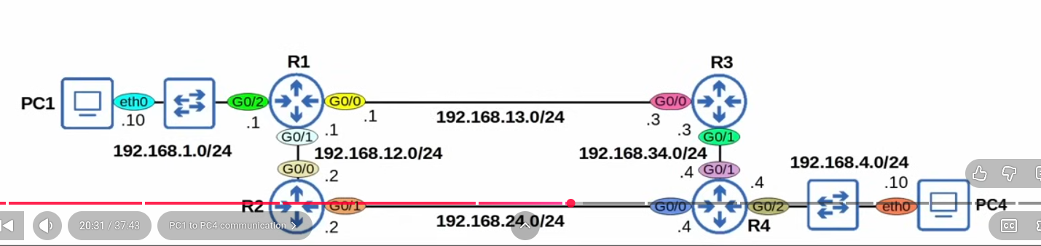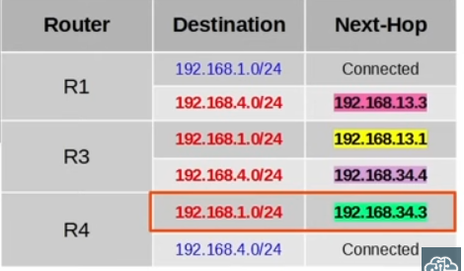
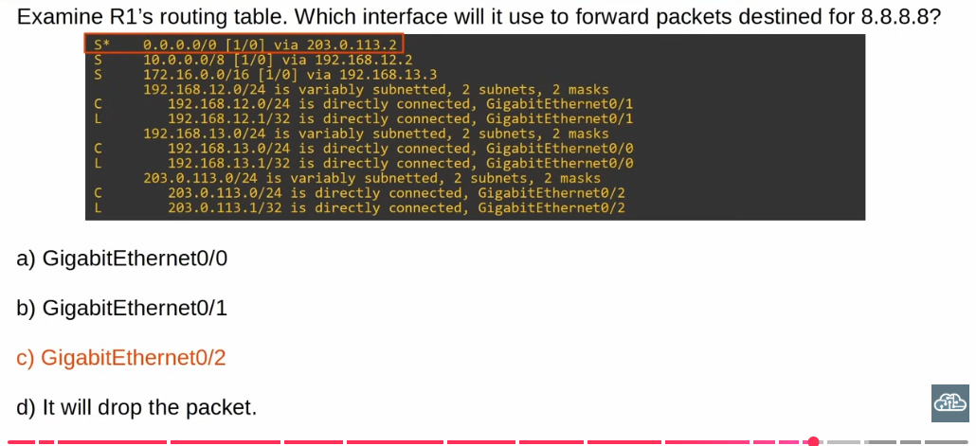

🔹 1. Basic Syntax to Remove a Static Route
no ip route [destination-network] [subnet-mask] [next-hop OR exit-interface]

🔹 2. Examples

✅ Case 1: Static Route with Next-Hop

Configured route:
ip route 192.168.2.0 255.255.255.0 10.0.0.2

Remove it:
no ip route 192.168.2.0 255.255.255.0 10.0.0.2

✅ Case 2: Static Route with Exit Interface

Configured route:
ip route 192.168.2.0 255.255.255.0 GigabitEthernet0/0

Remove it:
no ip route 192.168.2.0 255.255.255.0 GigabitEthernet0/0

✅ Case 3: Static Route with Both

Configured route:
ip route 192.168.2.0 255.255.255.0 GigabitEthernet0/0 10.0.0.2

Remove it:
no ip route 192.168.2.0 255.255.255.0 GigabitEthernet0/0 10.0.0.2

⚠️ Important Rule
👉 The command must match exactly how it was configured
Otherwise, the router will not remove it.

🔹 3. Removing a Default Route

Configured:
ip route 0.0.0.0 0.0.0.0 10.0.0.2

Remove:
no ip route 0.0.0.0 0.0.0.0 10.0.0.2

🔹 4. Steps in Cisco CLI
enable
configure terminal
no ip route 192.168.2.0 255.255.255.0 10.0.0.2
end

🔹 5. Verify Removal
show ip route
👉 The route should no longer appear.

🔹 6. Pro Tip (Exam & Real Life)
- If you forget how the route was configured:
show running-config | include ip route
👉 Look for:
ip route ...
Then copy it and add no in front.

🔥 Quick Summary
- Use no ip route to delete static routes
- Must match the original configuration exactly
- Works for:
  - Next-hop routes
  - Exit interface routes
  - Default routes

